Draft

- Call to Order

Mayor Ingalls called the meeting to order at 6:30 p.m.

Present: Mayor Jeff Ingalls

Councilmembers:
Lynnette Nash
Kim Boyum
Jim Potter

Others Present: City Clerk-Treasurer Gretchen Lohrbach
Public Works Lead Joe Adams
Public Works Wade Schroeder
Fire Chief Paul Lushinsky

- Pledge of Allegiance

Everyone stood and recited the Pledge of Allegiance.

- Changes to the Agenda

No changes

- Consent Agenda

  - Accounts Payable (Warrant List) for 1.26.26
  - County Commissioners Meeting Minutes 12.23.25
  - Council Meeting Minutes 1.12.16
  - Approval of Rental Units for 2026
  - EDA Meeting Minutes 10.20.25
  - EDA Metting Minutes 9.15.25
  - Park Board Minutes 10.28.25
  - Park Board Minutes 9.30.25

Councilmember Potter moved and Councilmember Nash seconded to approve the consent agenda as presented.

Motion carried: 4 ayes / 0 nays

- Proclamations, Presentations and Recognitions

No Items

- Public Concerns

- Brendon Kester is working on the annexation application for the Golf Course. He will get it to City Clerk Lohrbach after it is completed.

- Public Safety Update

- The Sheriff department said that they have two new hires coming on.

- Fire Chief Paul Lushinsky said that they are working on choosing a new grass rig. City Clerk Lohrbach will connect with the Taylor Family Farms Foundation to see if we can use the grant for the new truck. Wednesday night Councilmember Nash, Mayor Ingalls, and City Clerk Lohrbach can attend the 7:30 Fire Meeting.

- Public Hearings

No items.

- New Business

- Friends of Mantorville gave an update on the Pickleball Court at Slingerland Park. Todd Kieffer from CEDA said he had received a quote that it will cost approximately $23,000 for the sound proofing. Friends of Mantorville said that, at this point in the project, they do not have enough funds for this, so Kieffer is working on a grant for them. The City Council believes moving forward with their grant is a good idea. Martha Vrieze said that she has a quote where the soundproofing would cost considerably less. She also said that soundproof paddles and balls could be required. She will give City Clerk Lohrbach a list of costs and invoices Friends of Mantorville may have incurred before they began to reimburse the City to make up for the cost indiscrepancy of available funds. She would also like approval from the City to allow companies to hang advertising on the outside of the pickleball fences.

Councilmember Nash made a motion and Councilmember Potter seconded to approve advertising to be hung on the pickleball court.

Motion carried: 4 ayes / 0 nays

- Council discussed the City’s options for the Paid Family Medical Leave deduction from employee’s paychecks and the City’s contribution. City Clerk Lohrbach said the Council could choose one of the following:
- City pays both employees contribution and City’s contribution to equal the 0.66% amount due every payroll
- Employees pay 0.44% and City pay 0.22%
- City can decide on a different amount, but employees contribution can never be higher than 0.44%

Mayor Ingalls said that everywhere he has looked into this, the employees have had to pay the 0.44% so it is reasonable that the City also do this.

Councilmember Potter moved and Councilmember Boyum seconded to have the City pay the full contribution amount of 0.66% for this year, and then choose another option next year that can be built into the 2027 budget.

Motion carried: 3 ayes / 1 nay, Mayor Ingalls opposed

- The City’s Fee Schedule for 2026 was discussed and the food vender fee could increase to $100 for a permit from the City. Mayor Ingalls would like City Clerk Lohrbach to come up with a food truck policy and application. Restaurants located in Mantorville would not have to pay.

Mayor Ingalls would also like City Clerk Lohrbach to gather information on Fire Call Fees and Campground fees in other towns.

- Committee assignments were changed because of the open seat on Council and have been assigned thus far as:

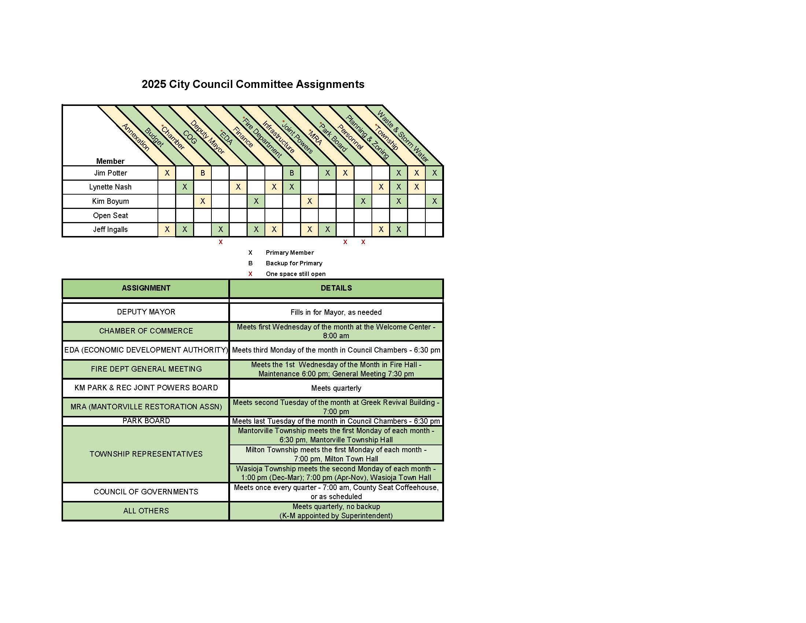
- No citizens were present wishing to discuss the proposed stop sign at the intersection of 8th Street East and Blanch Street. It will be discussed again at the February 9th meeting and a final decision will be made by Council.

- The calendar for 2026 was changed to show the 4th Monday every month as possible special meeting days if need be.

- Summary Budget was informational and not discussed.

- A vacancy was declared on City Council. Applications will be accepted until March 2nd and a decision will be made by Council at the meeting on March 9th. This will be posted on Facebook, the City Website, the newspaper, and at City Hall.

Councilmember Nash moved and Councilmember Potter seconded to approve Resolution 2026-06 Declaring a Vacancy on City Council.

Motion carried: 4 ayes / 0 nays

- Old Business

- The City’s Building Inspector with Construction Management Services has tried multiple times to reach Mr. Fyten regarding the inspection needed at his property at 101 5th Street East. Council voted to have City Clerk Lohrbach contact the City Attorney and proceed with a warrant.

Councilmember Potter moved and Councilmember Nash seconded to proceed with a warrant:

Motion carried: 4 ayes / 0 nays

- Tabled Items

- Streetlight on HWY 57 across from Casey’s was not pulled from the table.

- Reports

- Public Works Report

  - Saturday the 31st at noon is the snowmobile Ride For Wyatt at Riverside Park.

  - They have been plowing a lot so far this winter.

  - Public Works will check on the I & I flows in spring.

  - The East end of City Hall will need to be shut down for approximately 4 hours to fix the pump at City Hall. The tentative date for this is February 13th.

- City Clerk Report

  - Council had asked in a precious meeting about franchise fees in the City and City Clerk Lohrbach found that Cities cannot charge a franchise fee for telephone companies. All other franchises will remain the same.

- Consultant Report

No Items.

- Committee Reports

  - Chamber
    - The annual dinner has been rescheduled for February 12th. Lynnette Nash has tickets available at the Chocolate Shop. Jane Hardwick will be the speaker that evening and will be speaking about the Dodge County Foundation.

  - Economic Development Authority
- The February meeting was cancelled. They will be discussing the pickleball grant at their next meeting.

  - Finance/Budget

  - Fire Department
- Will be attending the monthly Council meetings.

  - Infrastructure

  - Kasson Mantorville Joint Powers
- Meets on Thursday February 29th.

  - Mantorville Restoration Association

  - Park Board
- Meets in March on the last Monday at 6:30pm.

  - Fire Relief

  - Personnel

  - Relief

  - Township

- Councilmember Reports

- Council said the new hockey rink at Riverside Park is being used all of the time. Councilmember Nash suggested a warming house for the skaters in the future.
- There was an obscene post made on the Fire Relief Facebook page. The page has been taken down until this can be addressed. Councilmember Boyum will send a picture of the post to City Clerk Lohrbach so that she can forward it to the Sheriff Department.

- Mayor’s Report

Mayor Ingalls said a massive amount of people have approached him about Lyle Hoaglund’s passing. He will be greatly missed.

- Executive session

Councilmember Boyum moved and Councilmember Potter seconded to move into executive session.

Motion carried: 4 ayes / 0 nays

Reviews were done regarding Deputy City Clerk Wendy Siewert’s and City Clerk Lohrbach’s 2025 performance.

Councilmember Nash moved and Councilmember Boyum seconded to end the executive session.

Councilmember Nash moved and Councilmember Boyum seconded to end the executive session.

Motion carried: 4 ayes / 0 nays

Councilmember Potter moved and Councilmember Boyum seconded to increase Deputy Siewert’s wage to $23.50 an hour.

Motion carried: 4ayes / 0 nays

Councilmember Potter moved and Councilmember Boyum seconded to give City Clerk Lohrbach an extra 0.75% raise to her salary along with the COLA raise.

Motion carried: 4 ayes / 0 nays

- Adjourn

Motion was made by Councilmember Potter and seconded by Councilmember
Boyum to adjourn the meeting at 9:20pm.

Motion carried: 4 ayes / 0 nays. Meeting adjourned.

_____________________________
Gretchen Lohrbach
City Clerk-Treasurer

