PARK AND RECREATION BOARD
Municipal Council Chambers | 21 5th Street E ● Mantorville, MN 55955
Tuesday, August 26, 2025 @ 6:30 PM

AGENDA

- Call to Order

- Adopt the Agenda

- Approval of Minutes
  - 7.31.2025 Park Minutes (Attachment A – page 2-4)

- Tabled/Revisit Items
  - Signs at Ballfields (Attachment B – page 5)

- Old Business
  - Grants
  - Riverside Park
- Hockey Rink / Basketball Court
- Bandshell
- Star
  - Walter & Ester Stussy Memorial Campground
  - Bergmann Park
  - Slingerland Park
- Pickleball
  - Mantor Field
  - K-M Dog Park
  - Denneson Field
  - Community Gardens
  - Community / Park Tree Management

- City Staff Updates / Reports

- Joint Ventures Updates

- Next board meeting is Tuesday, September 30, 2025 at 6:30 PM

- Adjourn
ATTACHMENT A

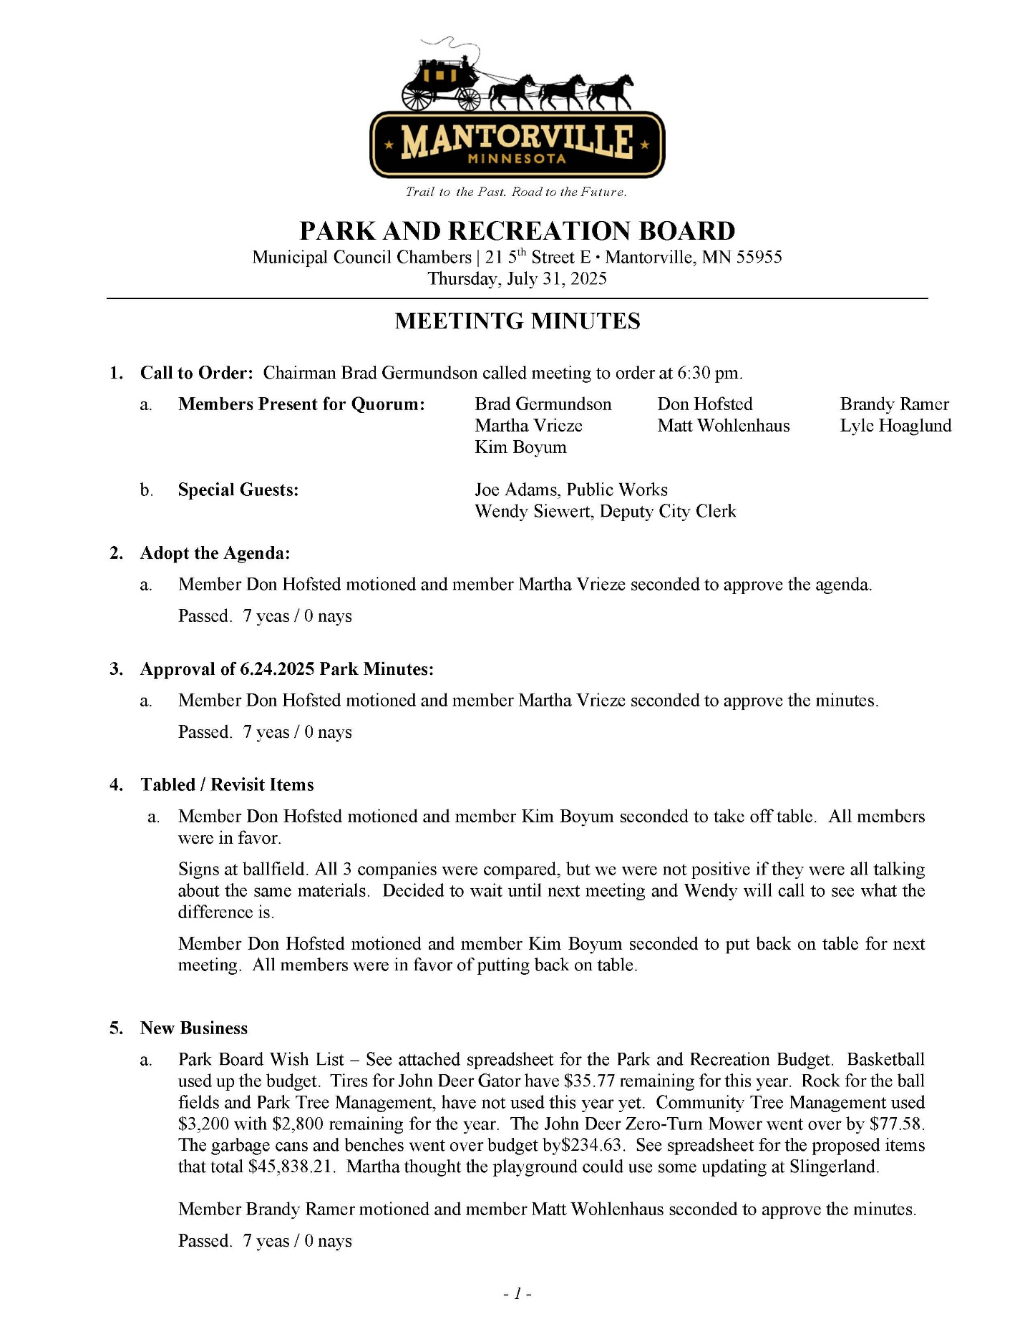
ATTACHMENT A (Continued)

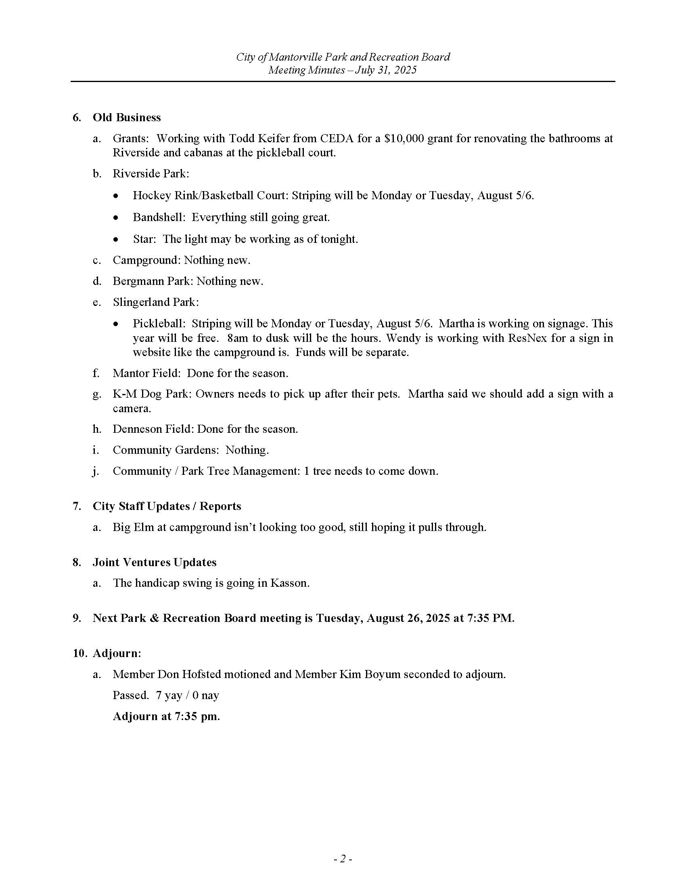
ATTACHMENT A (Continued)
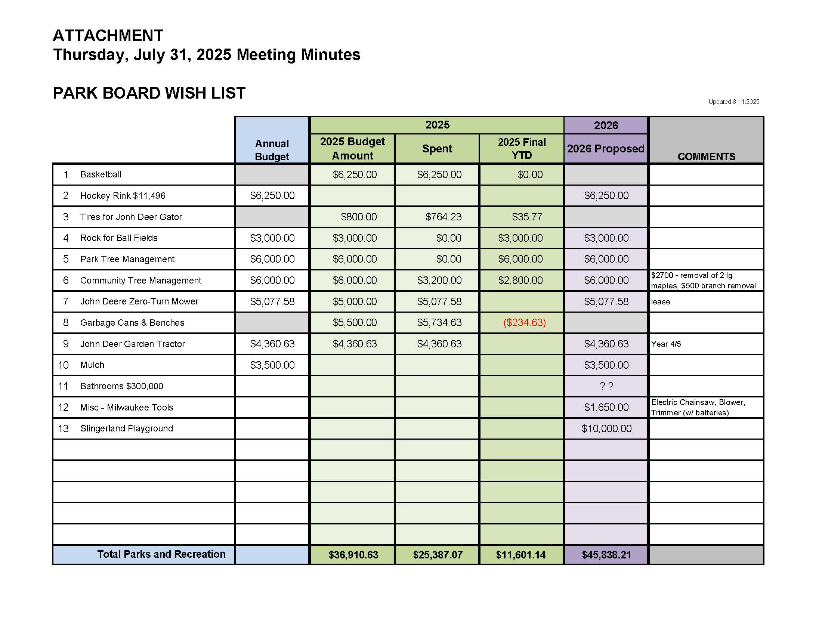

ATTACHMENT B

Signs at Ballfields
SIGNS | Midwest Signtech | Abel Signs
4X4 Poly Metal Signs  - Includes Art Setup (as long as they provide their logo in vector format)  - Includes Grommets  - Does not include Art Work | $185.00 | $300 (2 color)  $350 (multi color)

Upcharge for Businesses - $50

Annual Charge for Businesses - $150

