- Call to Order

Mayor Ingalls called the meeting to order at 6:30 p.m.

Present: Mayor Jeff Ingalls

Councilmembers:
Lynnette Nash
Lyle Hoaglund
Jim Potter
Kim Boyum

Absent: None

Others Present: City Clerk-Treasurer Gretchen Lohrbach
Public Works Lead Joe Adams
Public Works Wade Schroeder
Deputy City Clerk Wendy Siewert

- Pledge of Allegiance

Everyone stood and recited the Pledge of Allegiance.

- Changes to the Agenda

City Clerk Lohrbach would like Council’s approval to add the Harter’s Garbage Removal License Renewal Application and the Rental Renewal License Application for 601 Monroe Street to the Consent Agenda for approval.

Councilmember Hoaglund Moved and Councilmember Potter seconded to approve these items to be added to the Consent Agenda:

Motion carried: 5 ayes / 0 nays

- Consent Agenda

Motion was made by Councilmember Nash and seconded by Councilmember Hoaglund to approve the amended Consent Agenda, as presented:

- Accounts Payable (Warrant List) for 1.27.25
- Fire Dept. Member Meeting Minutes January 2025
- 2025 Garbage Hauler Permit Renewals
- County Commissioners Meeting Minutes 12.23.24
- Resolution 2025-05 Approving 508 Clay Street & 16 5th Street West Lot Line Rearrangement
- Approval of Rental License for 601 Monroe Court
- Approval of Garbage Hauler License renewal for Harter’s Disposal

Motion carried: 5 ayes / 0 nays

- Proclamations, Presentations and Recognitions
No Items

- Public Concerns
No Items

- Public Safety Update

  - Deputy Chief JJ Williams addressed Council in place of Fire Chief Annabelle Hardwick.

He is requesting to change the Fire Department Meeting Schedule to be:

1st Wednesday of every month – Maintenance 6:00pm & Regular 7:30pm
2nd & 3rd Wednesdays – Training 6:30pm
1st Tuesday Prior to 1st Wednesday of every month – Officers Meeting 7:00pm

Councilmember Nash moved and Councilmember Boyum seconded:

Motion carried: 5 ayes / 0 nays

  - JJ wanted to thank Councilmember Nash for her efforts to obtain donations for the Fire Department.

  - The Fire Department also received a $40,000 grant for Radios from the Minnesota Department of Public Safety.

Councilmember Potter moved and Councilmember Nash seconded to approve the grant monies that will be dispersed to the City:

Motion Carried: 5 ayes / 0 nays

- Public Hearings

The purpose of the public hearing is to hear from the public, consider, and thereafter act on a proposed text amendment to the city’s zoning regulations. The proposed amendment, Ordinance 2025-01 - An Ordinance Amending Title XI and Title XV of the Code of Ordinances Pertaining to Cannabis and Hemp Businesses, would establish certain zoning locations, regulations and limitations for various cannabis and hemp businesses within the city to an extent authorized under state law.

Motion was made by Councilmember Potter and seconded by Councilmember Hoaglund to open the public hearings at 6:38 pm.

Motion carried: 5 ayes / 0 nays.

Dodge County Public Health Representative Amy Evans was present to advise Council and give information on the Dodge County Cannabis Ordinance 24-01 Regulating Cannabis Businesses in Dodge County and the State Statutes regarding the new cannabis laws.

She reiterated that Mantorville cannot be more restrictive in their Ordinance than the State regarding setbacks and allowing potential sales in Mantorville.

Mayor Ingalls said that Mantorville can be restrictive, but not so much that a business is unable to locate here according to State Statute.

Motion was made by Councilmember Potter and seconded by Councilmember Hoaglund to close the public hearings at 7:22 pm.

Motion carried: 5 ayes / 0 nays.

Council returned to open session, discussed, and made motion on the following:

Councilmember Nash moved and Councilmember Potter seconded to table Ordinance 2025-01 until Council has a chance to gather some more information regarding City Zoning Ordinances and their clarity on this subject matter:

Motion Carried: 5 ayes / 0 nays

- Old Business/New Business

  - City Councilmember Committee Assignments were agreed upon.
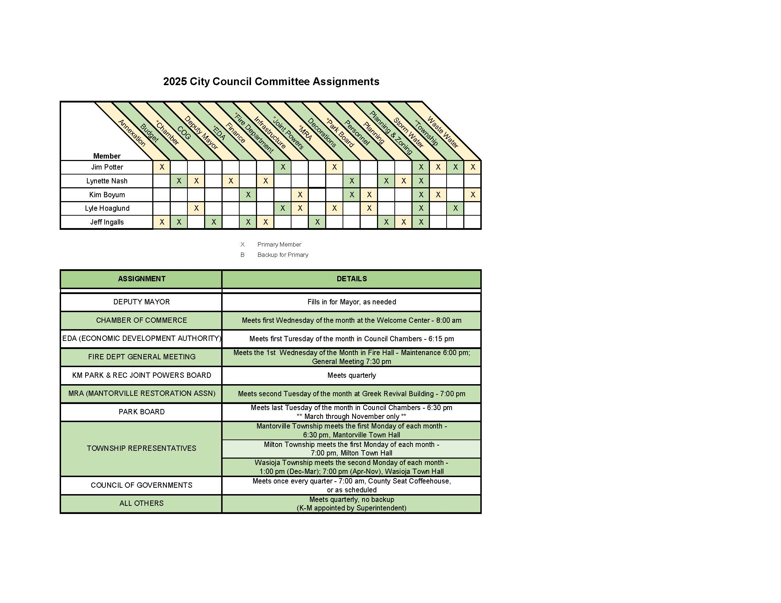
  - The resident at 140 State HWY 57 was present to discuss the damage to his sewer laterals during a project the City contracted out to Ellingson Drainage back in the summer of 2019 or 2020, so the City’s warranty period has passed. Had he approached Council when the issue was first noticed, this might have been covered.

He had sent three invoices to the City and he estimates his invoices and labor to fix this issue come to roughly $2,212.00.

Council advised him to get together a breakdown of his total costs and labor and to check with his insurance in case the issue would be covered by them. Then he could return to Council and discuss this issue in more detail.

  - Motion was made by Councilmember Nash and seconded by Councilmember Boyum to approve Resolution 2025-07, A Resolution Authorizing the Certification of Unpaid Charges to the Dodge County Auditor for a resident in the amount of $875.41.

Motion Carried: 5 ayes / 0 nays

- Tabled Items

  - Security cameras for City Hall, City Shop, and Fire Department.

No motion was made to pull this from the table.

- Reports

- Public Works Report
  - Publics Works has been cutting down the dead ash trees on Goat Island at Riverside Park.
  - Public Works Lead Adams wants to be present when the sewer line damage for 140 State HWY 57 is discussed.
  - Brush pick-up will be the week after Mother’s Day.
  - The new lawnmower has been purchased. The tires for the gator have not yet been ordered.

- City Clerk Report
  - Councilmember Boyum and Councilmember Nash have completed the LBAE training for the meeting in April. If other Councilmembers would like to be trained, they must complete this by January 31st.
  - The City Attorney is available for Council Training on March 10th.
  - The fee schedule for 2025 does not require a Public Hearing because it will not be changed.
  - Clerk Lohrbach asked if Council had given more thought to the potential donation of property to the City discussed at the previous meeting. This piece of land is worth approximately $2,700 on the tax rolls. Council instructed Lohrbach to have the City Attorney draw up papers for acceptance of the donation.
  - Lohrbach gave the Council information on the flow capacity for wastewater in the agreement with the City of Kasson.
  - Lohrbach reminded everyone of the informational meeting for the approved Pickleball Court to be constructed at Slingerland Park in the spring. It is Monday, February 10th at 6:30pm in Council Chambers.

- Consultant Report
No report

- Committee Reports
  - Chamber
    - The Annual Chamber Dinner went well. They have already had their first meeting about Christmastime activities for this year.
  - Economic Development Authority
  - Finance/Budget
  - Fire Department
  - Infrastructure
  - Kasson Mantorville Joint Powers
  - Mantorville Restoration Association
- Clerk Lohrbach will draw up a resolution for the donation of AED costs from the MRA to the Fire Department.
  - Park Board
- Next meeting is last Tuesday in March.
  - Personnel
  - Fire Relief
  - Township
  - Decorations
- City Clerk Lohrbach will again check with Xcel Energy about the HWY 57b lights. Adams and Hoaglund will check hook-up before she calls. Laura Qualey will be bringing the new CEDA representative to City Hall Monday to meet staff.

- Councilmember Reports

Councilmember Nash has been receiving positive input from residents about the approved Pickleball Court to be installed in Slingerland Park this spring.

Councilmember Potter has heard opposite opinions.

Councilmember Hoaglund looking into outdoor furnace systems burning wood and so did Clerk Lohrbach. It looks like these burners are allowed. Clerk Lohrbach will do more research when the permit application is submitted.

- Mayor’s Report

- Executive session
No Items

- Adjourn
Motion was made by Councilmember Nash and seconded by Councilmember
Potter to adjourn the meeting at 8:02 p.m.

Motion carried: 5 ayes / 0 nays. Meeting adjourned.

Approved: February 24, 2025.

_____________________________
Gretchen Lohrbach
City Clerk-Treasurer

